Blood of Christ I Trust in You - America-Prayer-Song
October 21st, 2020
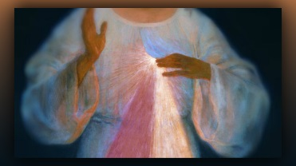
My Dear Family, the Lord has helped me put this prayer/song together with a beautiful melody, to help us pray for the President, our nation and the world which is at a critical crossroads. I wanted to make this recording better but that in fact would be vanity because this prayer is critical right now, and there’s not time for bells and whistles.

I am asking you to please, memorize this song and sing it over and over again, from your heart with contrition for our sins and the sins of our nation, as well as the world. Please, please spread this song far and wide, we are covering our nation with the power of the Blood of Christ and His Mercy. If we are going to defeat evil in the land, our prayers must be strong and continuous. I wish there were a way to make it go viral, but all we can really do is recommend it to everyone and sing it. Please download it and spread it all around. Lord, have You anything to say?

“Beloved, My Mercy is without end, just as My love for each of you who are precious in My sight. This is the time to make your voice heard in Heaven.

A few years ago, My Father came very close to putting an end to the evil on this earth and beginning the tribulation. But because of the passionate prayers and fasting of so many around the world, asking for Mercy, He relented and gave us more time, more grace and more mercy.

But now it is again your turn to step up and fill the gap of intercession with your prayers and contrition for the world. There must be repentance along with this prayer. There must be a recognition from Christians that have been treading water and lukewarm, that it is time to stop living for yourself and time to take your nation’s leaders seriously. Prayer moves the hand of My Father, repentance more than doubles it. Repent for your lives of excess and selfishness, your Luke warmness, and preoccupation with those things of the world that matter the least. Bring to mind this heart felt attitude when you sing this song and I promise you will be heard from on high.

We want nothing but good for you but your souls have been endangered by a short sighted and worldly lifestyle, and the things that have come upon this earth are a result of that, so that you will wake up and take your lives and your nation seriously before it is too late. I am with you and have spoken to your heart about the things in your lives that are ungodly. Now I am asking for repentance and prayer. Will you hear Me? Will you obey? Your lives, and the lives of your children hang in the balance at this hour. Make the difference that brings mercy upon the world. Sing this song, over and over again, and you will be heard.”

The Song is next to be posted.

The Lyrics:

Blood and Water from the Heart of Jesus,
fount of Mercy, I trust in You.
Save our Nation and our president too.
Blood of Christ, I trust in You.
Forgive our sins, the heart-of-our-land renew.
Save the world from all the wicked do.
Father of Mercy, I trust in You.

